From: IR Office <international.office@eu.edu.ge>
Sent: Wednesday, January 31, 2024 4:54 PM
Cc: Tatia Dolidze <tatia.dolidze@eu.edu.ge>
Subject: Noteworthy information for HEIs holding ECHE

I am reaching out to you from European University (Georgia), we are looking for new partners within the framework of the 2024 Erasmus+ International Credit Mobility programme.

In case some institutions seek a HEI from Neighbourhood East (Region 2) to team up with for their KA171 projects, we would gladly explore potential collaboration opportunities.

European University is a fast-growing and ambitious Georgian HEI that is well-integrated into the European education space and closely cooperates with the education systems of other regions of the world as well.

An Erasmus+ fact sheet along with the university brochure and the list of the projects are attached to this email for a more thorough examination.

Kind Regards,
Mariam Mania
International Projects and Bilateral Mobility Manager
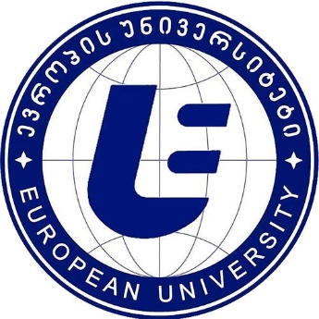
Tel: +995 32 2 000171 (147)
Mob: +995 577607378
Add: Guramishvili ave. 76, 0141, Tbilisi, Georgia
Web: www.eu.edu.ge

